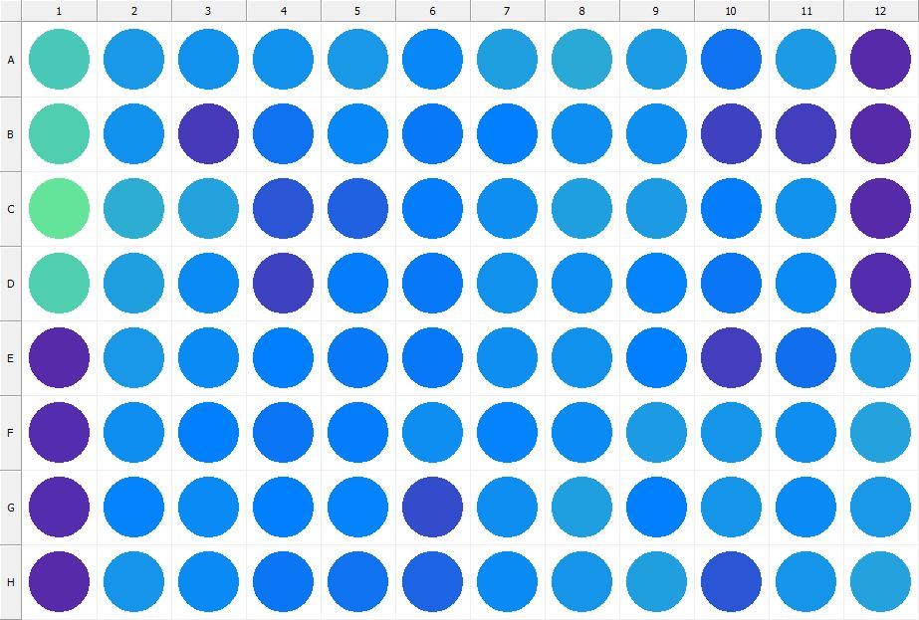

|  |
| --- |
| **Results for Tim_CTB(1) - channel 1 (RFU)** |

|  |  |  |  |  |  |  |  |  |  |  |  |  |
| --- | --- | --- | --- | --- | --- | --- | --- | --- | --- | --- | --- | --- |
|  | 01 | 02 | 03 | 04 | 05 | 06 | 07 | 08 | 09 | 10 | 11 | 12 |
| A | 135189 | 100947 | 97277 | 97261 | 101664 | 89834 | 107794 | 112896 | 103335 | 76771 | 103866 | 26820 |
| B | 139138 | 96400 | 40284 | 77478 | 89540 | 81647 | 86524 | 96008 | 94423 | 44635 | 42232 | 28405 |
| C | 152156 | 116674 | 110007 | 58295 | 64468 | 83250 | 95805 | 107451 | 105198 | 84458 | 97998 | 27333 |
| D | 138231 | 105950 | 93260 | 44191 | 83860 | 81424 | 96556 | 95249 | 88086 | 78898 | 91772 | 29051 |
| E | 28943 | 102317 | 93925 | 85991 | 81543 | 82118 | 94168 | 97680 | 85356 | 41765 | 75144 | 103235 |
| F | 30035 | 94305 | 86271 | 78730 | 83192 | 94204 | 88402 | 93040 | 104611 | 100256 | 94894 | 108206 |
| G | 29305 | 87538 | 92694 | 85060 | 87830 | 50175 | 94555 | 106898 | 86375 | 99446 | 92041 | 102747 |
| H | 28402 | 99630 | 92002 | 78761 | 76810 | 67382 | 93518 | 100132 | 106464 | 58865 | 98809 | 108257 |

|  |  |
| --- | --- |
| **Plate information** | |
|  | |
| **Plate** | 1 |
| **Repeat** | 1 |
| **Barcode** |  |
| **Measured height** | 14.78 |
| **Inside temperature at start** | 23.15 |
| **Inside temperature at end** | 23.15 |
| **Humidity at start** | 26.6 |
| **Humidity at end** | 26.4 |
| **Ambient temperature at start** | 22.95 |
| **Ambient temperature at end** | 22.86 |
| **Group** | 1 |
| **Label** | Tim_CTB(1) |
| **ScanX** | 0 |
| **ScanY** | 0 |
| **Measinfo** | De=1st Ex=Top Em=Top Wdw=N/A (14) |
| **Kinetics** | 0 |
| **Measurement date** | 12/12/2022 12:30:45 PM |
|  | |

|  |
| --- |
| **Background information** |
| Legend:  HDR1 - Plate  HDR2 - Label  HDR3 - Result  HDR4 - Signal  HDR5 - Flashes/Time  HDR6 - Meastime  HDR7 - MeasInfo |
| HDR1 HDR2 HDR3 HDR4 HDR5 HDR6 HDR7  1 Tim_CTB 0 1071 1 00:00:00.000 De=1st Ex=Top Em=Top Wdw=N/A (14) |
|  |

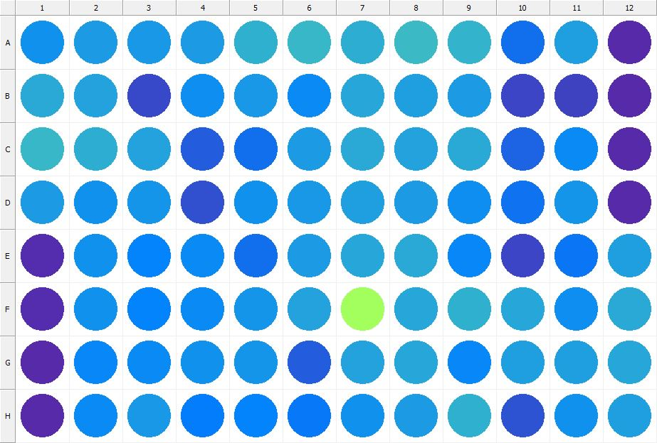

|  |
| --- |
| **Results for Tim_CTB(1) - channel 1 (RFU)** |

|  |  |  |  |  |  |  |  |  |  |  |  |  |
| --- | --- | --- | --- | --- | --- | --- | --- | --- | --- | --- | --- | --- |
|  | 01 | 02 | 03 | 04 | 05 | 06 | 07 | 08 | 09 | 10 | 11 | 12 |
| A | 98443 | 104242 | 101316 | 105342 | 117615 | 122698 | 115471 | 124449 | 121773 | 73507 | 107537 | 27935 |
| B | 114116 | 108660 | 47560 | 96254 | 102116 | 92974 | 111484 | 107550 | 103921 | 46265 | 43454 | 28764 |
| C | 122109 | 117090 | 109524 | 62961 | 74673 | 104033 | 112843 | 108774 | 112993 | 66774 | 92194 | 28626 |
| D | 104668 | 97483 | 100313 | 53573 | 96559 | 102417 | 105935 | 103605 | 94451 | 75869 | 100629 | 28835 |
| E | 29171 | 98028 | 88957 | 93884 | 75298 | 103398 | 111797 | 113067 | 91329 | 45440 | 78410 | 106236 |
| F | 29555 | 97246 | 89221 | 91801 | 100272 | 109820 | 194772 | 110928 | 118317 | 111996 | 94518 | 112731 |
| G | 28560 | 89652 | 92292 | 96601 | 100720 | 63103 | 109620 | 111706 | 89724 | 105620 | 107249 | 110521 |
| H | 28047 | 93189 | 101769 | 82810 | 88835 | 81836 | 97002 | 104748 | 119002 | 54521 | 98009 | 106620 |

|  |  |
| --- | --- |
| **Plate information** | |
|  | |
| **Plate** | 2 |
| **Repeat** | 1 |
| **Barcode** |  |
| **Measured height** | 14.78 |
| **Inside temperature at start** | 23.15 |
| **Inside temperature at end** | 23.15 |
| **Humidity at start** | 26.2 |
| **Humidity at end** | 26.2 |
| **Ambient temperature at start** | 22.86 |
| **Ambient temperature at end** | 22.86 |
| **Group** | 1 |
| **Label** | Tim_CTB(1) |
| **ScanX** | 0 |
| **ScanY** | 0 |
| **Measinfo** | De=1st Ex=Top Em=Top Wdw=N/A (14) |
| **Kinetics** | 0 |
| **Measurement date** | 12/12/2022 12:31:24 PM |
|  | |

|  |
| --- |
| **Background information** |
| Legend:  HDR1 - Plate  HDR2 - Label  HDR3 - Result  HDR4 - Signal  HDR5 - Flashes/Time  HDR6 - Meastime  HDR7 - MeasInfo |
| HDR1 HDR2 HDR3 HDR4 HDR5 HDR6 HDR7  2 Tim_CTB 0 1079 1 00:00:00.000 De=1st Ex=Top Em=Top Wdw=N/A (14) |
|  |

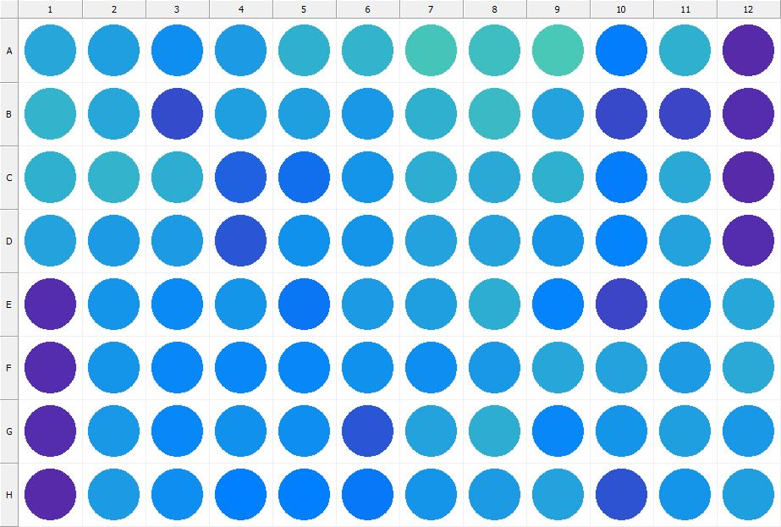

|  |
| --- |
| **Results for Tim_CTB(1) - channel 1 (RFU)** |

|  |  |  |  |  |  |  |  |  |  |  |  |  |
| --- | --- | --- | --- | --- | --- | --- | --- | --- | --- | --- | --- | --- |
|  | 01 | 02 | 03 | 04 | 05 | 06 | 07 | 08 | 09 | 10 | 11 | 12 |
| A | 112471 | 107692 | 95239 | 103864 | 118188 | 120123 | 132505 | 128009 | 135329 | 84091 | 117332 | 27826 |
| B | 120569 | 110436 | 51067 | 106860 | 105976 | 102831 | 118275 | 124335 | 109701 | 48051 | 45392 | 29578 |
| C | 117505 | 120909 | 115388 | 65640 | 73623 | 99338 | 116303 | 113940 | 117430 | 83345 | 112608 | 28338 |
| D | 108343 | 104110 | 104154 | 58291 | 97907 | 100168 | 109522 | 110026 | 100071 | 87413 | 109486 | 29525 |
| E | 29437 | 100004 | 93888 | 98712 | 79695 | 104857 | 107789 | 116036 | 88588 | 47208 | 96369 | 111608 |
| F | 29972 | 100501 | 89832 | 90784 | 91396 | 96389 | 95032 | 101075 | 110528 | 109071 | 105360 | 113617 |
| G | 29062 | 101334 | 91408 | 97570 | 95505 | 58014 | 108528 | 115491 | 90949 | 98825 | 107119 | 102938 |
| H | 28849 | 104408 | 95528 | 84692 | 84923 | 80581 | 98707 | 104879 | 109861 | 56217 | 99245 | 106394 |

|  |  |
| --- | --- |
| **Plate information** | |
|  | |
| **Plate** | 3 |
| **Repeat** | 1 |
| **Barcode** |  |
| **Measured height** | 14.78 |
| **Inside temperature at start** | 23.25 |
| **Inside temperature at end** | 23.25 |
| **Humidity at start** | 26.2 |
| **Humidity at end** | 26.2 |
| **Ambient temperature at start** | 22.76 |
| **Ambient temperature at end** | 22.86 |
| **Group** | 1 |
| **Label** | Tim_CTB(1) |
| **ScanX** | 0 |
| **ScanY** | 0 |
| **Measinfo** | De=1st Ex=Top Em=Top Wdw=N/A (14) |
| **Kinetics** | 0 |
| **Measurement date** | 12/12/2022 12:32:14 PM |
|  | |

|  |
| --- |
| **Background information** |
| Legend:  HDR1 - Plate  HDR2 - Label  HDR3 - Result  HDR4 - Signal  HDR5 - Flashes/Time  HDR6 - Meastime  HDR7 - MeasInfo |
| HDR1 HDR2 HDR3 HDR4 HDR5 HDR6 HDR7  3 Tim_CTB 0 1214 1 00:00:00.000 De=1st Ex=Top Em=Top Wdw=N/A (14) |
|  |

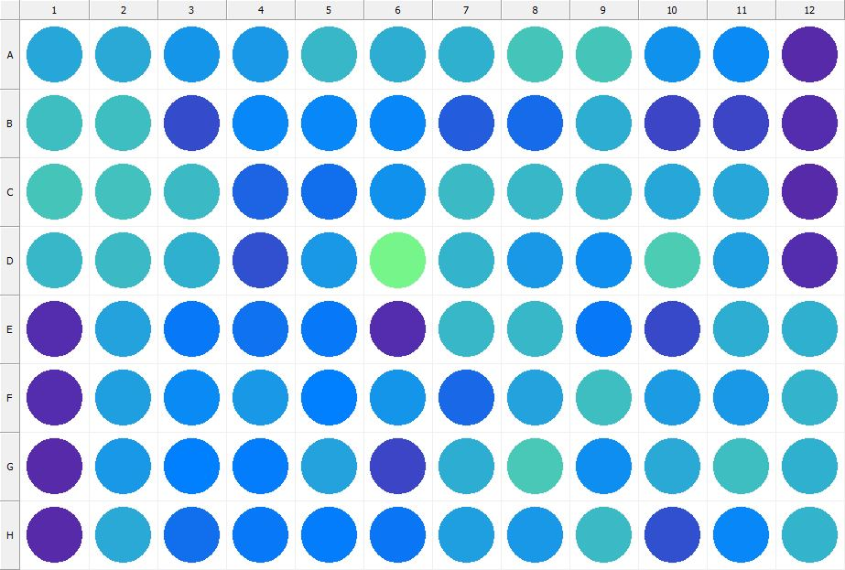

|  |
| --- |
| **Results for Tim_CTB(1) - channel 1 (RFU)** |

|  |  |  |  |  |  |  |  |  |  |  |  |  |
| --- | --- | --- | --- | --- | --- | --- | --- | --- | --- | --- | --- | --- |
|  | 01 | 02 | 03 | 04 | 05 | 06 | 07 | 08 | 09 | 10 | 11 | 12 |
| A | 110851 | 113155 | 100388 | 101666 | 122272 | 116829 | 118472 | 133334 | 131652 | 97284 | 92453 | 27924 |
| B | 128690 | 126572 | 51978 | 91578 | 90845 | 89562 | 62584 | 71199 | 115261 | 45905 | 47054 | 29960 |
| C | 131796 | 129254 | 126132 | 66669 | 73589 | 97626 | 125730 | 122008 | 117990 | 111294 | 111465 | 28438 |
| D | 122045 | 125027 | 118009 | 54429 | 102986 | 165785 | 121694 | 101555 | 94009 | 136520 | 105994 | 30244 |
| E | 29554 | 109824 | 81201 | 77554 | 81708 | 31057 | 122731 | 122226 | 81498 | 48717 | 115941 | 118466 |
| F | 30225 | 107684 | 91767 | 101079 | 86576 | 100595 | 68593 | 109647 | 128106 | 105296 | 101468 | 120688 |
| G | 28583 | 101798 | 86586 | 82926 | 108630 | 46280 | 115931 | 134639 | 95780 | 112958 | 127669 | 117605 |
| H | 28392 | 112819 | 74580 | 82196 | 84140 | 77894 | 106108 | 102473 | 124792 | 54450 | 91467 | 121132 |

|  |  |
| --- | --- |
| **Plate information** | |
|  | |
| **Plate** | 4 |
| **Repeat** | 1 |
| **Barcode** |  |
| **Measured height** | 14.78 |
| **Inside temperature at start** | 23.25 |
| **Inside temperature at end** | 23.25 |
| **Humidity at start** | 26.2 |
| **Humidity at end** | 26.2 |
| **Ambient temperature at start** | 22.86 |
| **Ambient temperature at end** | 22.95 |
| **Group** | 1 |
| **Label** | Tim_CTB(1) |
| **ScanX** | 0 |
| **ScanY** | 0 |
| **Measinfo** | De=1st Ex=Top Em=Top Wdw=N/A (14) |
| **Kinetics** | 0 |
| **Measurement date** | 12/12/2022 12:32:57 PM |
|  | |

|  |
| --- |
| **Background information** |
| Legend:  HDR1 - Plate  HDR2 - Label  HDR3 - Result  HDR4 - Signal  HDR5 - Flashes/Time  HDR6 - Meastime  HDR7 - MeasInfo |
| HDR1 HDR2 HDR3 HDR4 HDR5 HDR6 HDR7  4 Tim_CTB 0 1075 1 00:00:00.000 De=1st Ex=Top Em=Top Wdw=N/A (14) |
|  |

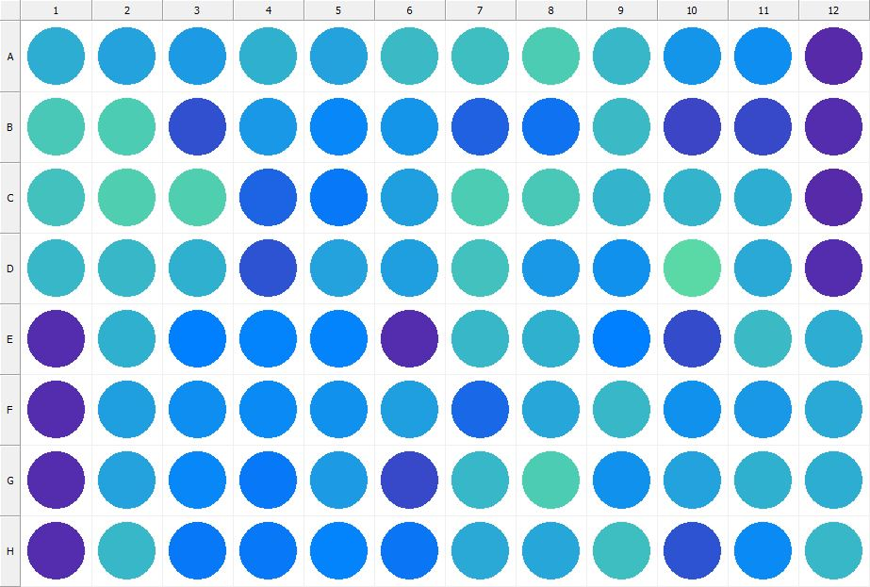

|  |
| --- |
| **Results for Tim_CTB(1) - channel 1 (RFU)** |

|  |  |  |  |  |  |  |  |  |  |  |  |  |
| --- | --- | --- | --- | --- | --- | --- | --- | --- | --- | --- | --- | --- |
|  | 01 | 02 | 03 | 04 | 05 | 06 | 07 | 08 | 09 | 10 | 11 | 12 |
| A | 116482 | 109026 | 103663 | 119316 | 108732 | 126040 | 128345 | 136724 | 122005 | 100793 | 95414 | 27856 |
| B | 135135 | 137614 | 52507 | 101540 | 89666 | 99334 | 66053 | 75729 | 125501 | 45903 | 47961 | 29618 |
| C | 131019 | 140271 | 138606 | 67356 | 81759 | 106285 | 136925 | 134742 | 120004 | 121305 | 116853 | 28434 |
| D | 122331 | 122494 | 118617 | 55794 | 108639 | 106321 | 129120 | 102274 | 98065 | 147078 | 114198 | 29414 |
| E | 29825 | 117874 | 84856 | 88806 | 88398 | 29984 | 123921 | 118753 | 85385 | 50042 | 125912 | 115760 |
| F | 30751 | 106095 | 95492 | 92026 | 98140 | 107687 | 69960 | 112470 | 124083 | 98293 | 102890 | 113773 |
| G | 29557 | 108123 | 90147 | 80679 | 104953 | 48317 | 123334 | 135832 | 96408 | 110160 | 118493 | 116330 |
| H | 29361 | 123098 | 80774 | 80443 | 87336 | 79006 | 113706 | 111973 | 128102 | 56684 | 93849 | 122728 |

|  |  |
| --- | --- |
| **Plate information** | |
|  | |
| **Plate** | 5 |
| **Repeat** | 1 |
| **Barcode** |  |
| **Measured height** | 14.78 |
| **Inside temperature at start** | 23.25 |
| **Inside temperature at end** | 23.25 |
| **Humidity at start** | 26.2 |
| **Humidity at end** | 26.4 |
| **Ambient temperature at start** | 23.05 |
| **Ambient temperature at end** | 22.86 |
| **Group** | 1 |
| **Label** | Tim_CTB(1) |
| **ScanX** | 0 |
| **ScanY** | 0 |
| **Measinfo** | De=1st Ex=Top Em=Top Wdw=N/A (14) |
| **Kinetics** | 0 |
| **Measurement date** | 12/12/2022 12:33:38 PM |
|  | |

|  |
| --- |
| **Background information** |
| Legend:  HDR1 - Plate  HDR2 - Label  HDR3 - Result  HDR4 - Signal  HDR5 - Flashes/Time  HDR6 - Meastime  HDR7 - MeasInfo |
| HDR1 HDR2 HDR3 HDR4 HDR5 HDR6 HDR7  5 Tim_CTB 0 1061 1 00:00:00.000 De=1st Ex=Top Em=Top Wdw=N/A (14) |
|  |

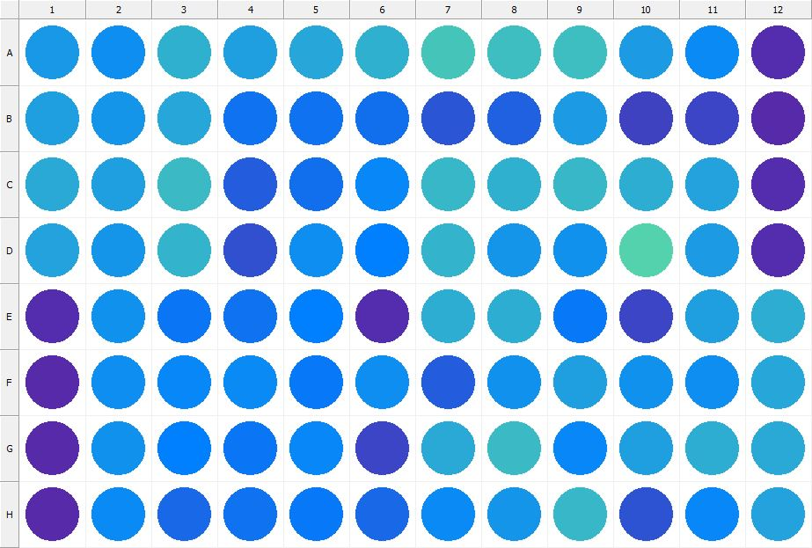

|  |
| --- |
| **Results for Tim_CTB(1) - channel 1 (RFU)** |

|  |  |  |  |  |  |  |  |  |  |  |  |  |
| --- | --- | --- | --- | --- | --- | --- | --- | --- | --- | --- | --- | --- |
|  | 01 | 02 | 03 | 04 | 05 | 06 | 07 | 08 | 09 | 10 | 11 | 12 |
| A | 102665 | 95627 | 117475 | 107472 | 111138 | 118924 | 132169 | 127733 | 126481 | 104200 | 93010 | 29234 |
| B | 107394 | 99710 | 111386 | 77582 | 76024 | 73514 | 58542 | 64020 | 103766 | 43158 | 45732 | 28578 |
| C | 112808 | 106527 | 124302 | 62257 | 74987 | 90900 | 123598 | 118923 | 122966 | 115277 | 108116 | 29010 |
| D | 108832 | 99956 | 120351 | 53790 | 94354 | 86954 | 120112 | 99318 | 96822 | 142621 | 103876 | 29917 |
| E | 29228 | 98262 | 79682 | 76986 | 86909 | 30700 | 115086 | 116933 | 80026 | 47111 | 105821 | 115592 |
| F | 28695 | 95535 | 89515 | 93765 | 80556 | 94390 | 62203 | 98049 | 106778 | 97788 | 94650 | 110950 |
| G | 28238 | 96718 | 86067 | 79432 | 91043 | 45434 | 113072 | 125327 | 90308 | 105614 | 115947 | 113959 |
| H | 28826 | 91798 | 69536 | 76527 | 81097 | 69865 | 93757 | 99958 | 123721 | 55205 | 90031 | 108611 |

|  |  |
| --- | --- |
| **Plate information** | |
|  | |
| **Plate** | 6 |
| **Repeat** | 1 |
| **Barcode** |  |
| **Measured height** | 14.78 |
| **Inside temperature at start** | 23.25 |
| **Inside temperature at end** | 23.27 |
| **Humidity at start** | 26.4 |
| **Humidity at end** | 26.6 |
| **Ambient temperature at start** | 22.76 |
| **Ambient temperature at end** | 22.78 |
| **Group** | 1 |
| **Label** | Tim_CTB(1) |
| **ScanX** | 0 |
| **ScanY** | 0 |
| **Measinfo** | De=1st Ex=Top Em=Top Wdw=N/A (14) |
| **Kinetics** | 0 |
| **Measurement date** | 12/12/2022 12:34:17 PM |
|  | |

|  |
| --- |
| **Background information** |
| Legend:  HDR1 - Plate  HDR2 - Label  HDR3 - Result  HDR4 - Signal  HDR5 - Flashes/Time  HDR6 - Meastime  HDR7 - MeasInfo |
| HDR1 HDR2 HDR3 HDR4 HDR5 HDR6 HDR7  6 Tim_CTB 0 1030 1 00:00:00.000 De=1st Ex=Top Em=Top Wdw=N/A (14) |
|  |

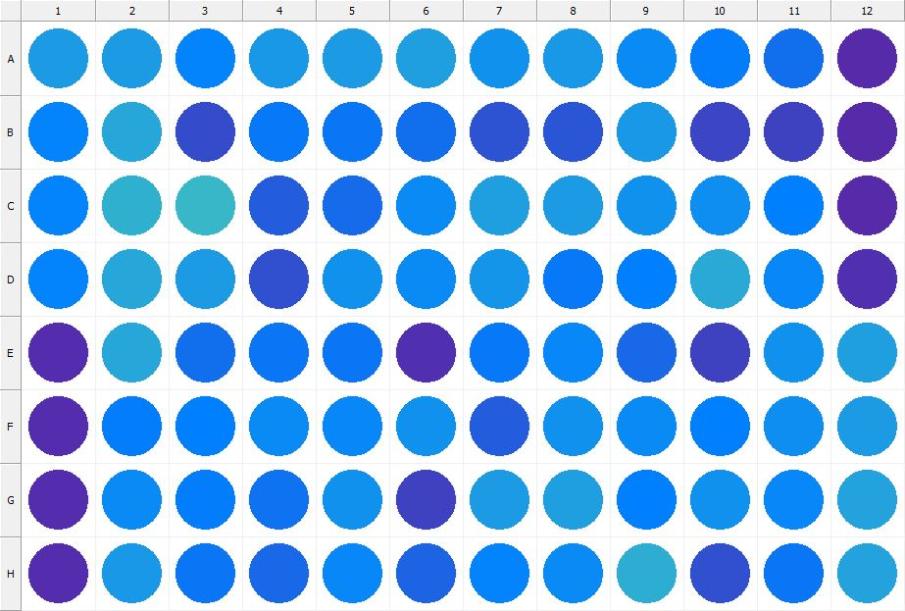

|  |
| --- |
| **Results for Tim_CTB(1) - channel 1 (RFU)** |

|  |  |  |  |  |  |  |  |  |  |  |  |  |
| --- | --- | --- | --- | --- | --- | --- | --- | --- | --- | --- | --- | --- |
|  | 01 | 02 | 03 | 04 | 05 | 06 | 07 | 08 | 09 | 10 | 11 | 12 |
| A | 103334 | 104416 | 88765 | 102077 | 103877 | 106759 | 96739 | 101115 | 91954 | 83638 | 74444 | 28574 |
| B | 89213 | 111074 | 49995 | 80945 | 79546 | 74575 | 55512 | 57796 | 100906 | 45862 | 44269 | 28527 |
| C | 89206 | 117959 | 121985 | 63713 | 72117 | 93791 | 106035 | 103752 | 98384 | 95895 | 86817 | 28589 |
| D | 88122 | 111611 | 104554 | 53404 | 98025 | 92100 | 99966 | 81121 | 84924 | 113001 | 89510 | 31972 |
| E | 30982 | 111621 | 74784 | 78746 | 79137 | 33059 | 81056 | 91162 | 68527 | 44983 | 97054 | 106634 |
| F | 30359 | 83395 | 86307 | 91864 | 89684 | 98408 | 61933 | 97158 | 92171 | 85979 | 95643 | 104964 |
| G | 30422 | 92484 | 83037 | 77664 | 97659 | 43437 | 104025 | 105965 | 85612 | 96970 | 90906 | 110147 |
| H | 29392 | 102520 | 78276 | 69688 | 91531 | 67686 | 87731 | 92227 | 115924 | 52658 | 79970 | 108989 |

|  |  |
| --- | --- |
| **Plate information** | |
|  | |
| **Plate** | 7 |
| **Repeat** | 1 |
| **Barcode** |  |
| **Measured height** | 14.78 |
| **Inside temperature at start** | 23.25 |
| **Inside temperature at end** | 23.25 |
| **Humidity at start** | 26.4 |
| **Humidity at end** | 26.6 |
| **Ambient temperature at start** | 22.95 |
| **Ambient temperature at end** | 22.95 |
| **Group** | 1 |
| **Label** | Tim_CTB(1) |
| **ScanX** | 0 |
| **ScanY** | 0 |
| **Measinfo** | De=1st Ex=Top Em=Top Wdw=N/A (14) |
| **Kinetics** | 0 |
| **Measurement date** | 12/12/2022 12:34:57 PM |
|  | |

|  |
| --- |
| **Background information** |
| Legend:  HDR1 - Plate  HDR2 - Label  HDR3 - Result  HDR4 - Signal  HDR5 - Flashes/Time  HDR6 - Meastime  HDR7 - MeasInfo |
| HDR1 HDR2 HDR3 HDR4 HDR5 HDR6 HDR7  7 Tim_CTB 0 1056 1 00:00:00.000 De=1st Ex=Top Em=Top Wdw=N/A (14) |
|  |

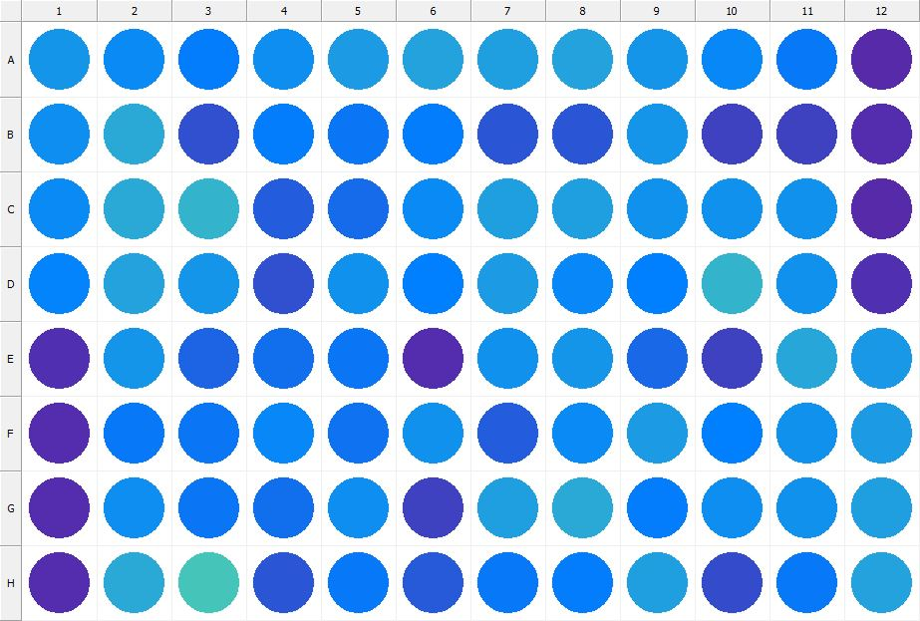

|  |
| --- |
| **Results for Tim_CTB(1) - channel 1 (RFU)** |

|  |  |  |  |  |  |  |  |  |  |  |  |  |
| --- | --- | --- | --- | --- | --- | --- | --- | --- | --- | --- | --- | --- |
|  | 01 | 02 | 03 | 04 | 05 | 06 | 07 | 08 | 09 | 10 | 11 | 12 |
| A | 99275 | 93051 | 82960 | 95951 | 104606 | 108142 | 106192 | 108448 | 98763 | 89329 | 80501 | 28180 |
| B | 95390 | 113920 | 52813 | 82939 | 78806 | 83359 | 57417 | 58722 | 100011 | 44890 | 45168 | 29065 |
| C | 93059 | 114467 | 119618 | 63561 | 70787 | 92413 | 105843 | 106275 | 96943 | 97512 | 96731 | 27989 |
| D | 87810 | 109554 | 99149 | 53351 | 97537 | 85138 | 104170 | 90831 | 86941 | 120400 | 97800 | 31319 |
| E | 31615 | 99468 | 67043 | 73140 | 79525 | 30445 | 96607 | 99290 | 70611 | 44848 | 111408 | 101103 |
| F | 30746 | 82302 | 78396 | 91432 | 77677 | 97817 | 61936 | 93520 | 103655 | 85827 | 96865 | 103919 |
| G | 29069 | 94475 | 79183 | 74035 | 94940 | 44137 | 106938 | 113937 | 82855 | 95228 | 98266 | 105910 |
| H | 29655 | 112824 | 131648 | 58540 | 80821 | 59366 | 80066 | 84318 | 107113 | 50618 | 81407 | 108579 |

|  |  |
| --- | --- |
| **Plate information** | |
|  | |
| **Plate** | 8 |
| **Repeat** | 1 |
| **Barcode** |  |
| **Measured height** | 14.78 |
| **Inside temperature at start** | 23.25 |
| **Inside temperature at end** | 23.34 |
| **Humidity at start** | 26.2 |
| **Humidity at end** | 26.2 |
| **Ambient temperature at start** | 22.86 |
| **Ambient temperature at end** | 22.95 |
| **Group** | 1 |
| **Label** | Tim_CTB(1) |
| **ScanX** | 0 |
| **ScanY** | 0 |
| **Measinfo** | De=1st Ex=Top Em=Top Wdw=N/A (14) |
| **Kinetics** | 0 |
| **Measurement date** | 12/12/2022 12:35:35 PM |
|  | |

|  |
| --- |
| **Background information** |
| Legend:  HDR1 - Plate  HDR2 - Label  HDR3 - Result  HDR4 - Signal  HDR5 - Flashes/Time  HDR6 - Meastime  HDR7 - MeasInfo |
| HDR1 HDR2 HDR3 HDR4 HDR5 HDR6 HDR7  8 Tim_CTB 0 1120 1 00:00:00.000 De=1st Ex=Top Em=Top Wdw=N/A (14) |
|  |

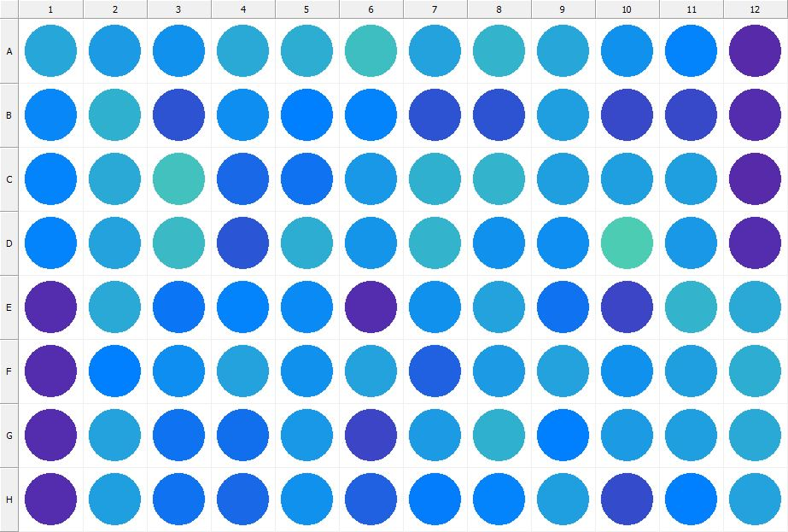

|  |
| --- |
| **Results for Tim_CTB(1) - channel 1 (RFU)** |

|  |  |  |  |  |  |  |  |  |  |  |  |  |
| --- | --- | --- | --- | --- | --- | --- | --- | --- | --- | --- | --- | --- |
|  | 01 | 02 | 03 | 04 | 05 | 06 | 07 | 08 | 09 | 10 | 11 | 12 |
| A | 111996 | 103948 | 96755 | 114140 | 115629 | 128167 | 108051 | 120391 | 111546 | 97484 | 87665 | 28720 |
| B | 91427 | 117751 | 56078 | 94020 | 85102 | 87703 | 55921 | 56325 | 107478 | 47664 | 48031 | 29382 |
| C | 87002 | 114489 | 130060 | 69174 | 76704 | 101079 | 119348 | 119790 | 106953 | 107527 | 106558 | 28094 |
| D | 89186 | 109611 | 124707 | 57071 | 116750 | 100470 | 120622 | 96705 | 95462 | 137261 | 101902 | 31201 |
| E | 30646 | 112883 | 79797 | 88308 | 93667 | 29611 | 98280 | 109407 | 76330 | 46272 | 119692 | 114650 |
| F | 30004 | 85390 | 95802 | 108263 | 96373 | 109729 | 65884 | 104576 | 110061 | 96978 | 105757 | 115963 |
| G | 29025 | 110092 | 76787 | 73830 | 103058 | 45705 | 104248 | 118454 | 86322 | 103894 | 107138 | 114730 |
| H | 29745 | 106614 | 77277 | 69466 | 96622 | 64381 | 83453 | 87528 | 107597 | 50929 | 85910 | 109764 |

|  |  |
| --- | --- |
| **Plate information** | |
|  | |
| **Plate** | 9 |
| **Repeat** | 1 |
| **Barcode** |  |
| **Measured height** | 14.78 |
| **Inside temperature at start** | 23.34 |
| **Inside temperature at end** | 23.34 |
| **Humidity at start** | 26.1 |
| **Humidity at end** | 26.1 |
| **Ambient temperature at start** | 23.15 |
| **Ambient temperature at end** | 23.15 |
| **Group** | 1 |
| **Label** | Tim_CTB(1) |
| **ScanX** | 0 |
| **ScanY** | 0 |
| **Measinfo** | De=1st Ex=Top Em=Top Wdw=N/A (14) |
| **Kinetics** | 0 |
| **Measurement date** | 12/12/2022 12:36:13 PM |
|  | |

|  |
| --- |
| **Background information** |
| Legend:  HDR1 - Plate  HDR2 - Label  HDR3 - Result  HDR4 - Signal  HDR5 - Flashes/Time  HDR6 - Meastime  HDR7 - MeasInfo |
| HDR1 HDR2 HDR3 HDR4 HDR5 HDR6 HDR7  9 Tim_CTB 0 1070 1 00:00:00.000 De=1st Ex=Top Em=Top Wdw=N/A (14) |
|  |

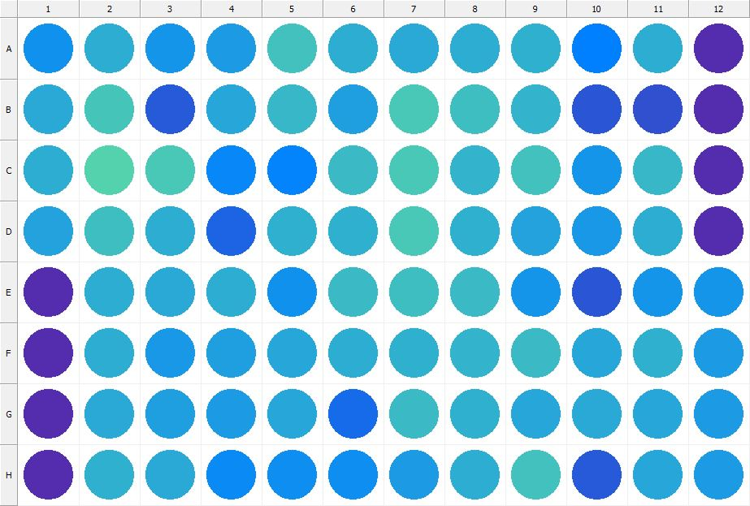

|  |
| --- |
| **Results for Tim_CTB(1) - channel 1 (RFU)** |

|  |  |  |  |  |  |  |  |  |  |  |  |  |
| --- | --- | --- | --- | --- | --- | --- | --- | --- | --- | --- | --- | --- |
|  | 01 | 02 | 03 | 04 | 05 | 06 | 07 | 08 | 09 | 10 | 11 | 12 |
| A | 97305 | 116348 | 99486 | 104433 | 130062 | 116556 | 114666 | 115713 | 117580 | 84823 | 116578 | 29166 |
| B | 113027 | 131607 | 60073 | 110676 | 121933 | 107813 | 134498 | 127650 | 119626 | 58437 | 54053 | 30700 |
| C | 116332 | 141362 | 134068 | 90143 | 87740 | 124902 | 133757 | 120480 | 129563 | 99872 | 122816 | 29196 |
| D | 108453 | 127810 | 115223 | 67877 | 117520 | 118434 | 133756 | 119314 | 109467 | 101972 | 115922 | 30319 |
| E | 30982 | 114979 | 113869 | 116067 | 97192 | 124180 | 127321 | 124146 | 100110 | 59132 | 100066 | 98988 |
| F | 30436 | 115342 | 101902 | 107177 | 110895 | 116860 | 117492 | 120419 | 124663 | 112134 | 118679 | 103756 |
| G | 29602 | 113529 | 105678 | 103820 | 110470 | 71423 | 124238 | 117633 | 112484 | 113355 | 111045 | 105091 |
| H | 29771 | 119436 | 114773 | 91634 | 95094 | 94852 | 105047 | 115921 | 128749 | 60598 | 110769 | 103797 |

|  |  |
| --- | --- |
| **Plate information** | |
|  | |
| **Plate** | 10 |
| **Repeat** | 1 |
| **Barcode** |  |
| **Measured height** | 14.78 |
| **Inside temperature at start** | 23.34 |
| **Inside temperature at end** | 23.34 |
| **Humidity at start** | 26.1 |
| **Humidity at end** | 26.1 |
| **Ambient temperature at start** | 23.05 |
| **Ambient temperature at end** | 22.95 |
| **Group** | 1 |
| **Label** | Tim_CTB(1) |
| **ScanX** | 0 |
| **ScanY** | 0 |
| **Measinfo** | De=1st Ex=Top Em=Top Wdw=N/A (14) |
| **Kinetics** | 0 |
| **Measurement date** | 12/12/2022 12:36:51 PM |
|  | |

|  |
| --- |
| **Background information** |
| Legend:  HDR1 - Plate  HDR2 - Label  HDR3 - Result  HDR4 - Signal  HDR5 - Flashes/Time  HDR6 - Meastime  HDR7 - MeasInfo |
| HDR1 HDR2 HDR3 HDR4 HDR5 HDR6 HDR7  10 Tim_CTB 0 1136 1 00:00:00.000 De=1st Ex=Top Em=Top Wdw=N/A (14) |
|  |

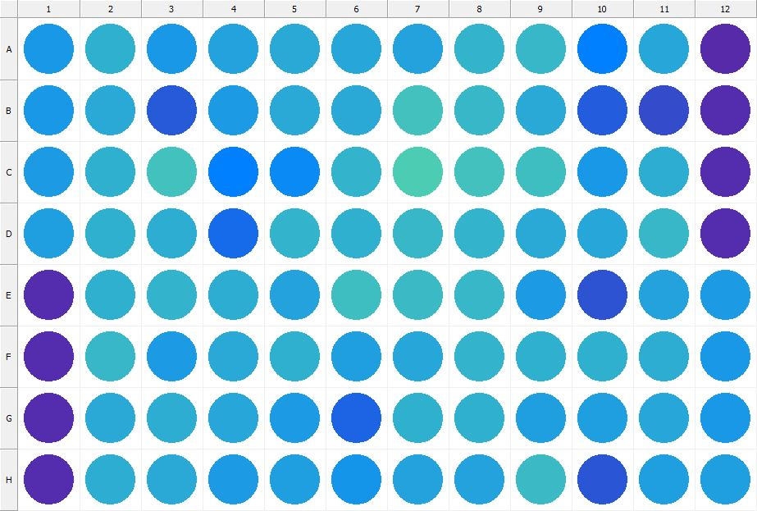

|  |
| --- |
| **Results for Tim_CTB(1) - channel 1 (RFU)** |

|  |  |  |  |  |  |  |  |  |  |  |  |  |
| --- | --- | --- | --- | --- | --- | --- | --- | --- | --- | --- | --- | --- |
|  | 01 | 02 | 03 | 04 | 05 | 06 | 07 | 08 | 09 | 10 | 11 | 12 |
| A | 101964 | 119158 | 101972 | 109984 | 112628 | 112320 | 108428 | 121611 | 122362 | 86928 | 110998 | 28433 |
| B | 102605 | 113121 | 59252 | 104196 | 114132 | 112724 | 128783 | 123696 | 112680 | 62106 | 51992 | 30597 |
| C | 104097 | 117263 | 130198 | 86948 | 92516 | 121634 | 136869 | 130775 | 128094 | 102999 | 116669 | 29169 |
| D | 107174 | 117820 | 115351 | 72607 | 120526 | 118511 | 123348 | 120923 | 113486 | 111171 | 122044 | 30381 |
| E | 30904 | 117455 | 120643 | 115750 | 107904 | 127888 | 124506 | 123774 | 103967 | 55168 | 108288 | 105068 |
| F | 30090 | 122558 | 104788 | 113318 | 119324 | 107751 | 111836 | 120144 | 119032 | 119245 | 116776 | 101683 |
| G | 29776 | 113638 | 115118 | 112114 | 103305 | 68384 | 119132 | 118925 | 107551 | 106883 | 112463 | 102122 |
| H | 29335 | 116036 | 113084 | 103888 | 106468 | 99921 | 108376 | 109555 | 124682 | 57294 | 107394 | 106652 |

|  |  |
| --- | --- |
| **Plate information** | |
|  | |
| **Plate** | 11 |
| **Repeat** | 1 |
| **Barcode** |  |
| **Measured height** | 14.78 |
| **Inside temperature at start** | 23.34 |
| **Inside temperature at end** | 23.34 |
| **Humidity at start** | 25.9 |
| **Humidity at end** | 25.9 |
| **Ambient temperature at start** | 23.05 |
| **Ambient temperature at end** | 23.15 |
| **Group** | 1 |
| **Label** | Tim_CTB(1) |
| **ScanX** | 0 |
| **ScanY** | 0 |
| **Measinfo** | De=1st Ex=Top Em=Top Wdw=N/A (14) |
| **Kinetics** | 0 |
| **Measurement date** | 12/12/2022 12:37:57 PM |
|  | |

|  |
| --- |
| **Background information** |
| Legend:  HDR1 - Plate  HDR2 - Label  HDR3 - Result  HDR4 - Signal  HDR5 - Flashes/Time  HDR6 - Meastime  HDR7 - MeasInfo |
| HDR1 HDR2 HDR3 HDR4 HDR5 HDR6 HDR7  11 Tim_CTB 0 1202 1 00:00:00.000 De=1st Ex=Top Em=Top Wdw=N/A (14) |
|  |

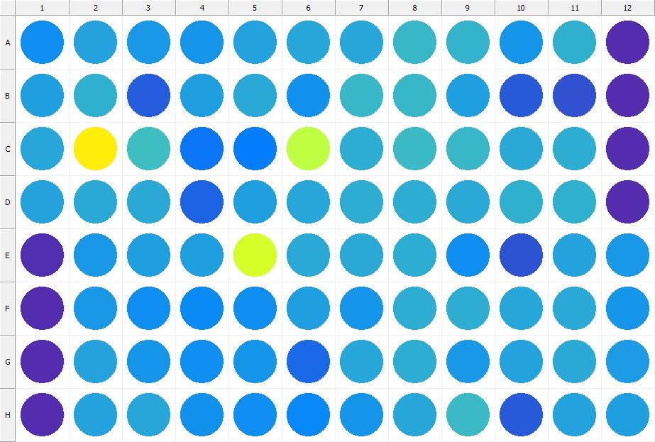

|  |
| --- |
| **Results for Tim_CTB(1) - channel 1 (RFU)** |

|  |  |  |  |  |  |  |  |  |  |  |  |  |
| --- | --- | --- | --- | --- | --- | --- | --- | --- | --- | --- | --- | --- |
|  | 01 | 02 | 03 | 04 | 05 | 06 | 07 | 08 | 09 | 10 | 11 | 12 |
| A | 94900 | 109408 | 102179 | 99456 | 108066 | 111349 | 112407 | 122804 | 121497 | 99684 | 117809 | 29492 |
| B | 107038 | 117481 | 63286 | 107729 | 113910 | 96650 | 122151 | 121783 | 106026 | 61068 | 52341 | 30733 |
| C | 112091 | 269813 | 126961 | 79749 | 84348 | 214144 | 116916 | 125967 | 123648 | 113089 | 115960 | 29340 |
| D | 109737 | 113734 | 113188 | 67563 | 107734 | 110298 | 115584 | 115954 | 113115 | 118724 | 119115 | 30293 |
| E | 31510 | 102444 | 106618 | 107198 | 229990 | 113193 | 113776 | 116251 | 96250 | 56277 | 108109 | 101698 |
| F | 30848 | 101579 | 94514 | 92586 | 94233 | 106895 | 100249 | 116247 | 115314 | 112411 | 113164 | 100606 |
| G | 30558 | 108476 | 100294 | 94528 | 100787 | 69174 | 112453 | 115188 | 102255 | 109965 | 113156 | 104726 |
| H | 30367 | 109424 | 111649 | 96920 | 96162 | 90643 | 100550 | 112492 | 125416 | 60312 | 109778 | 106613 |

|  |  |
| --- | --- |
| **Plate information** | |
|  | |
| **Plate** | 12 |
| **Repeat** | 1 |
| **Barcode** |  |
| **Measured height** | 14.78 |
| **Inside temperature at start** | 23.34 |
| **Inside temperature at end** | 23.34 |
| **Humidity at start** | 26.2 |
| **Humidity at end** | 26.2 |
| **Ambient temperature at start** | 23.05 |
| **Ambient temperature at end** | 23.15 |
| **Group** | 1 |
| **Label** | Tim_CTB(1) |
| **ScanX** | 0 |
| **ScanY** | 0 |
| **Measinfo** | De=1st Ex=Top Em=Top Wdw=N/A (14) |
| **Kinetics** | 0 |
| **Measurement date** | 12/12/2022 12:38:36 PM |
|  | |

|  |
| --- |
| **Background information** |
| Legend:  HDR1 - Plate  HDR2 - Label  HDR3 - Result  HDR4 - Signal  HDR5 - Flashes/Time  HDR6 - Meastime  HDR7 - MeasInfo |
| HDR1 HDR2 HDR3 HDR4 HDR5 HDR6 HDR7  12 Tim_CTB 0 1127 1 00:00:00.000 De=1st Ex=Top Em=Top Wdw=N/A (14) |
|  |

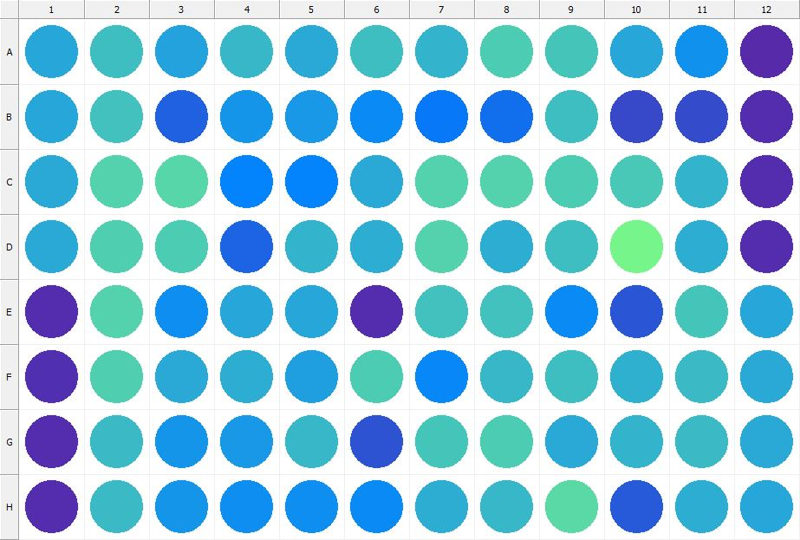

|  |
| --- |
| **Results for Tim_CTB(1) - channel 1 (RFU)** |

|  |  |  |  |  |  |  |  |  |  |  |  |  |
| --- | --- | --- | --- | --- | --- | --- | --- | --- | --- | --- | --- | --- |
|  | 01 | 02 | 03 | 04 | 05 | 06 | 07 | 08 | 09 | 10 | 11 | 12 |
| A | 110251 | 128345 | 108922 | 122360 | 113860 | 128555 | 120307 | 136390 | 132096 | 111045 | 96753 | 28152 |
| B | 110275 | 129915 | 65506 | 100270 | 100923 | 93363 | 81757 | 74814 | 127284 | 49810 | 50452 | 30058 |
| C | 113531 | 142598 | 143686 | 88412 | 89266 | 114492 | 141513 | 142586 | 136350 | 133776 | 121052 | 29803 |
| D | 113520 | 139581 | 136926 | 67050 | 120217 | 116457 | 140538 | 115021 | 126840 | 163745 | 116173 | 30714 |
| E | 31121 | 140457 | 95762 | 110787 | 111415 | 29706 | 129677 | 129993 | 92395 | 57962 | 132791 | 111817 |
| F | 31526 | 138543 | 114030 | 116921 | 106650 | 136983 | 90283 | 123062 | 127987 | 119045 | 124386 | 114116 |
| G | 29464 | 125316 | 99006 | 101223 | 123114 | 55720 | 131093 | 136239 | 114179 | 121768 | 124690 | 114803 |
| H | 29817 | 124863 | 99068 | 94225 | 95818 | 92905 | 115761 | 122573 | 146885 | 59654 | 115778 | 110893 |

|  |  |
| --- | --- |
| **Plate information** | |
|  | |
| **Plate** | 13 |
| **Repeat** | 1 |
| **Barcode** |  |
| **Measured height** | 14.78 |
| **Inside temperature at start** | 23.34 |
| **Inside temperature at end** | 23.36 |
| **Humidity at start** | 26.1 |
| **Humidity at end** | 26.2 |
| **Ambient temperature at start** | 23.15 |
| **Ambient temperature at end** | 23.27 |
| **Group** | 1 |
| **Label** | Tim_CTB(1) |
| **ScanX** | 0 |
| **ScanY** | 0 |
| **Measinfo** | De=1st Ex=Top Em=Top Wdw=N/A (14) |
| **Kinetics** | 0 |
| **Measurement date** | 12/12/2022 12:39:23 PM |
|  | |

|  |
| --- |
| **Background information** |
| Legend:  HDR1 - Plate  HDR2 - Label  HDR3 - Result  HDR4 - Signal  HDR5 - Flashes/Time  HDR6 - Meastime  HDR7 - MeasInfo |
| HDR1 HDR2 HDR3 HDR4 HDR5 HDR6 HDR7  13 Tim_CTB 0 1084 1 00:00:00.000 De=1st Ex=Top Em=Top Wdw=N/A (14) |
|  |

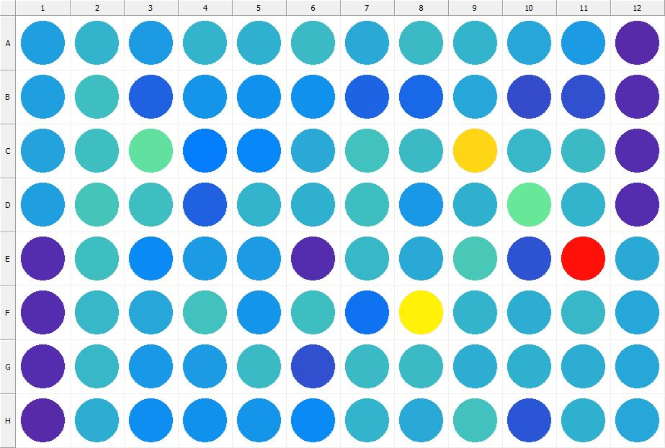

|  |
| --- |
| **Results for Tim_CTB(1) - channel 1 (RFU)** |

|  |  |  |  |  |  |  |  |  |  |  |  |  |
| --- | --- | --- | --- | --- | --- | --- | --- | --- | --- | --- | --- | --- |
|  | 01 | 02 | 03 | 04 | 05 | 06 | 07 | 08 | 09 | 10 | 11 | 12 |
| A | 106555 | 121548 | 104227 | 120785 | 118666 | 124143 | 114028 | 124546 | 121195 | 110447 | 104821 | 28461 |
| B | 107615 | 128260 | 64021 | 99298 | 97227 | 98029 | 67745 | 68610 | 112242 | 52162 | 52900 | 30270 |
| C | 109555 | 127285 | 150525 | 84612 | 90622 | 112536 | 130757 | 125587 | 285316 | 122103 | 125850 | 29536 |
| D | 107803 | 131224 | 127962 | 65335 | 121394 | 117586 | 126638 | 101356 | 117753 | 155284 | 119950 | 30308 |
| E | 30529 | 126597 | 91672 | 103315 | 104391 | 30220 | 123162 | 114186 | 133737 | 54587 | 416673 | 113209 |
| F | 29442 | 123054 | 111650 | 130384 | 100291 | 127752 | 76500 | 267465 | 121547 | 114841 | 123843 | 111614 |
| G | 30013 | 122216 | 102212 | 103332 | 125193 | 54289 | 125355 | 124451 | 116100 | 119348 | 117135 | 110543 |
| H | 28851 | 116553 | 94597 | 97389 | 100430 | 92200 | 119585 | 114393 | 130064 | 58611 | 118541 | 111380 |

|  |  |
| --- | --- |
| **Plate information** | |
|  | |
| **Plate** | 14 |
| **Repeat** | 1 |
| **Barcode** |  |
| **Measured height** | 14.78 |
| **Inside temperature at start** | 23.34 |
| **Inside temperature at end** | 23.34 |
| **Humidity at start** | 26.2 |
| **Humidity at end** | 26.2 |
| **Ambient temperature at start** | 22.95 |
| **Ambient temperature at end** | 22.95 |
| **Group** | 1 |
| **Label** | Tim_CTB(1) |
| **ScanX** | 0 |
| **ScanY** | 0 |
| **Measinfo** | De=1st Ex=Top Em=Top Wdw=N/A (14) |
| **Kinetics** | 0 |
| **Measurement date** | 12/12/2022 12:40:07 PM |
|  | |

|  |
| --- |
| **Background information** |
| Legend:  HDR1 - Plate  HDR2 - Label  HDR3 - Result  HDR4 - Signal  HDR5 - Flashes/Time  HDR6 - Meastime  HDR7 - MeasInfo |
| HDR1 HDR2 HDR3 HDR4 HDR5 HDR6 HDR7  14 Tim_CTB 0 1110 1 00:00:00.000 De=1st Ex=Top Em=Top Wdw=N/A (14) |
|  |

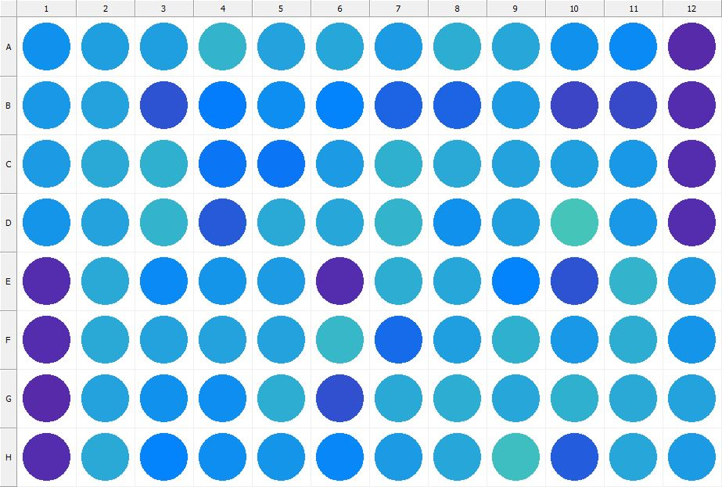

|  |
| --- |
| **Results for Tim_CTB(1) - channel 1 (RFU)** |

|  |  |  |  |  |  |  |  |  |  |  |  |  |
| --- | --- | --- | --- | --- | --- | --- | --- | --- | --- | --- | --- | --- |
|  | 01 | 02 | 03 | 04 | 05 | 06 | 07 | 08 | 09 | 10 | 11 | 12 |
| A | 96612 | 107740 | 105569 | 120378 | 109114 | 111612 | 104418 | 114954 | 111721 | 97229 | 93870 | 28701 |
| B | 101901 | 108517 | 55991 | 82818 | 94465 | 87491 | 68267 | 67858 | 103898 | 47112 | 48969 | 29107 |
| C | 104303 | 113850 | 119183 | 79446 | 79632 | 105482 | 117435 | 113186 | 107888 | 107187 | 101646 | 29239 |
| D | 99172 | 110069 | 119457 | 61019 | 114024 | 110635 | 121074 | 97977 | 107693 | 132253 | 101531 | 30892 |
| E | 30066 | 114803 | 91970 | 98838 | 104658 | 30240 | 114854 | 112301 | 88115 | 55391 | 120027 | 103303 |
| F | 31218 | 113635 | 108404 | 108992 | 107999 | 122504 | 70915 | 107826 | 118204 | 102250 | 115812 | 99569 |
| G | 28834 | 108495 | 98486 | 93996 | 117105 | 53244 | 114227 | 115342 | 110846 | 118416 | 114354 | 109217 |
| H | 30367 | 114459 | 88092 | 94421 | 98731 | 91620 | 104809 | 111103 | 127144 | 61542 | 111114 | 104820 |

|  |  |
| --- | --- |
| **Plate information** | |
|  | |
| **Plate** | 15 |
| **Repeat** | 1 |
| **Barcode** |  |
| **Measured height** | 14.78 |
| **Inside temperature at start** | 23.34 |
| **Inside temperature at end** | 23.34 |
| **Humidity at start** | 26.2 |
| **Humidity at end** | 26.2 |
| **Ambient temperature at start** | 22.86 |
| **Ambient temperature at end** | 22.95 |
| **Group** | 1 |
| **Label** | Tim_CTB(1) |
| **ScanX** | 0 |
| **ScanY** | 0 |
| **Measinfo** | De=1st Ex=Top Em=Top Wdw=N/A (14) |
| **Kinetics** | 0 |
| **Measurement date** | 12/12/2022 12:43:04 PM |
|  | |

|  |
| --- |
| **Background information** |
| Legend:  HDR1 - Plate  HDR2 - Label  HDR3 - Result  HDR4 - Signal  HDR5 - Flashes/Time  HDR6 - Meastime  HDR7 - MeasInfo |
| HDR1 HDR2 HDR3 HDR4 HDR5 HDR6 HDR7  16 Tim_CTB 0 1046 1 00:00:00.000 De=1st Ex=Top Em=Top Wdw=N/A (14) |
|  |

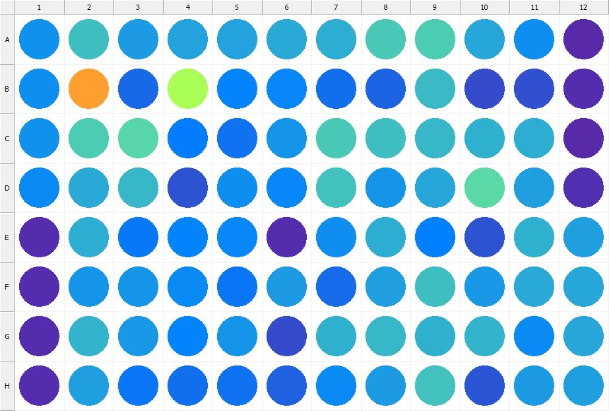

|  |
| --- |
| **Results for Tim_CTB(1) - channel 1 (RFU)** |

|  |  |  |  |  |  |  |  |  |  |  |  |  |
| --- | --- | --- | --- | --- | --- | --- | --- | --- | --- | --- | --- | --- |
|  | 01 | 02 | 03 | 04 | 05 | 06 | 07 | 08 | 09 | 10 | 11 | 12 |
| A | 97445 | 127622 | 104435 | 109315 | 108628 | 113623 | 116062 | 134796 | 137620 | 111181 | 96204 | 28587 |
| B | 94190 | 322786 | 68551 | 200335 | 87341 | 90096 | 73413 | 67415 | 125523 | 51115 | 52233 | 30411 |
| C | 97962 | 136010 | 143231 | 83593 | 76644 | 100054 | 135650 | 126913 | 121927 | 117282 | 116358 | 28616 |
| D | 93400 | 114289 | 122393 | 56503 | 95359 | 91528 | 130356 | 100867 | 112357 | 146497 | 105644 | 32628 |
| E | 30998 | 115755 | 81917 | 87398 | 91461 | 30430 | 95393 | 116945 | 86146 | 55226 | 118349 | 106008 |
| F | 31119 | 99813 | 100376 | 92440 | 79839 | 104359 | 71233 | 106510 | 127355 | 100903 | 112744 | 111641 |
| G | 29424 | 121519 | 102932 | 88287 | 100407 | 50341 | 119097 | 122964 | 117306 | 121143 | 92687 | 111302 |
| H | 31012 | 107568 | 79549 | 74984 | 75761 | 66082 | 92382 | 105314 | 130508 | 56944 | 104677 | 105760 |

|  |  |
| --- | --- |
| **Plate information** | |
|  | |
| **Plate** | 16 |
| **Repeat** | 1 |
| **Barcode** |  |
| **Measured height** | 14.78 |
| **Inside temperature at start** | 23.34 |
| **Inside temperature at end** | 23.34 |
| **Humidity at start** | 26.1 |
| **Humidity at end** | 26.1 |
| **Ambient temperature at start** | 22.66 |
| **Ambient temperature at end** | 22.86 |
| **Group** | 1 |
| **Label** | Tim_CTB(1) |
| **ScanX** | 0 |
| **ScanY** | 0 |
| **Measinfo** | De=1st Ex=Top Em=Top Wdw=N/A (14) |
| **Kinetics** | 0 |
| **Measurement date** | 12/12/2022 12:44:38 PM |
|  | |

|  |
| --- |
| **Background information** |
| Legend:  HDR1 - Plate  HDR2 - Label  HDR3 - Result  HDR4 - Signal  HDR5 - Flashes/Time  HDR6 - Meastime  HDR7 - MeasInfo |
| HDR1 HDR2 HDR3 HDR4 HDR5 HDR6 HDR7  17 Tim_CTB 0 1006 1 00:00:00.000 De=1st Ex=Top Em=Top Wdw=N/A (14) |
|  |

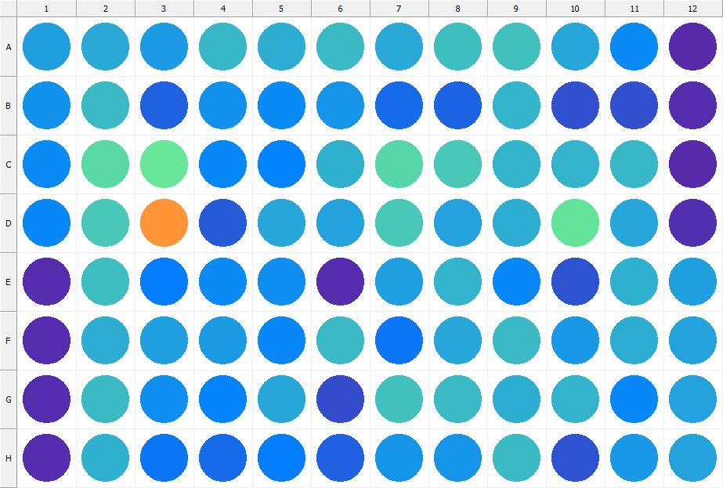

|  |
| --- |
| **Results for Tim_CTB(1) - channel 1 (RFU)** |

|  |  |  |  |  |  |  |  |  |  |  |  |  |
| --- | --- | --- | --- | --- | --- | --- | --- | --- | --- | --- | --- | --- |
|  | 01 | 02 | 03 | 04 | 05 | 06 | 07 | 08 | 09 | 10 | 11 | 12 |
| A | 107322 | 114255 | 103448 | 122056 | 115927 | 124254 | 114552 | 127401 | 129622 | 110652 | 92013 | 28993 |
| B | 96306 | 125979 | 65148 | 98397 | 92746 | 99980 | 71700 | 67044 | 119551 | 52677 | 54389 | 30216 |
| C | 93526 | 146982 | 155110 | 90380 | 87881 | 117399 | 143458 | 135265 | 119477 | 120180 | 123113 | 28852 |
| D | 91080 | 134850 | 330468 | 59390 | 112375 | 110167 | 133963 | 110087 | 116638 | 152689 | 110405 | 32334 |
| E | 30830 | 127281 | 82650 | 93936 | 95713 | 30510 | 107631 | 120517 | 90712 | 56073 | 119322 | 106581 |
| F | 31002 | 116220 | 106916 | 104724 | 91089 | 124818 | 78262 | 112084 | 124720 | 101970 | 116804 | 109156 |
| G | 29802 | 126293 | 95346 | 89157 | 112212 | 50771 | 129423 | 124234 | 116489 | 120766 | 90657 | 109799 |
| H | 30693 | 118998 | 79888 | 72301 | 84400 | 65826 | 99046 | 99859 | 125370 | 56080 | 102996 | 109456 |

|  |  |
| --- | --- |
| **Plate information** | |
|  | |
| **Plate** | 17 |
| **Repeat** | 1 |
| **Barcode** |  |
| **Measured height** | 14.78 |
| **Inside temperature at start** | 23.34 |
| **Inside temperature at end** | 23.36 |
| **Humidity at start** | 25.9 |
| **Humidity at end** | 26.1 |
| **Ambient temperature at start** | 22.86 |
| **Ambient temperature at end** | 22.97 |
| **Group** | 1 |
| **Label** | Tim_CTB(1) |
| **ScanX** | 0 |
| **ScanY** | 0 |
| **Measinfo** | De=1st Ex=Top Em=Top Wdw=N/A (14) |
| **Kinetics** | 0 |
| **Measurement date** | 12/12/2022 12:45:21 PM |
|  | |

|  |
| --- |
| **Background information** |
| Legend:  HDR1 - Plate  HDR2 - Label  HDR3 - Result  HDR4 - Signal  HDR5 - Flashes/Time  HDR6 - Meastime  HDR7 - MeasInfo |
| HDR1 HDR2 HDR3 HDR4 HDR5 HDR6 HDR7  18 Tim_CTB 0 1147 1 00:00:00.000 De=1st Ex=Top Em=Top Wdw=N/A (14) |
|  |

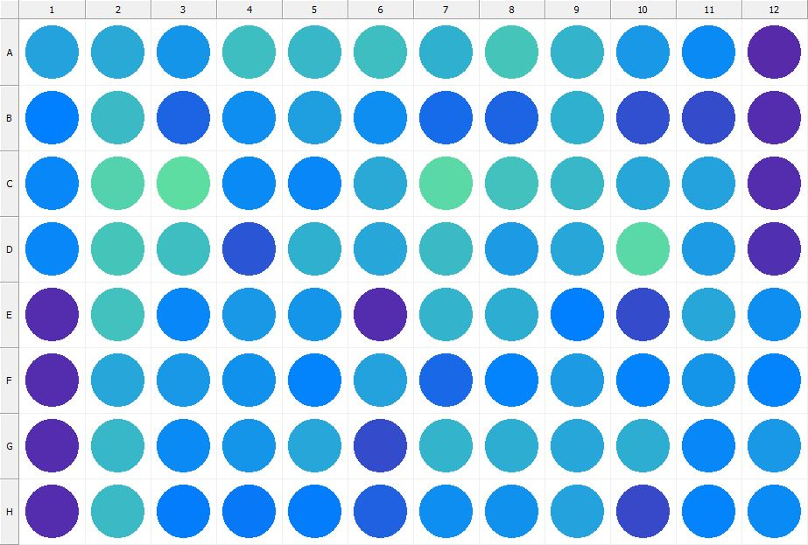

|  |
| --- |
| **Results for Tim_CTB(1) - channel 1 (RFU)** |

|  |  |  |  |  |  |  |  |  |  |  |  |  |
| --- | --- | --- | --- | --- | --- | --- | --- | --- | --- | --- | --- | --- |
|  | 01 | 02 | 03 | 04 | 05 | 06 | 07 | 08 | 09 | 10 | 11 | 12 |
| A | 108862 | 113838 | 100842 | 128699 | 122261 | 128315 | 117736 | 131294 | 121660 | 101030 | 93727 | 28229 |
| B | 86926 | 124971 | 67314 | 95676 | 106129 | 95969 | 72844 | 67754 | 118882 | 54317 | 50273 | 30388 |
| C | 90090 | 141241 | 147408 | 93265 | 90611 | 114027 | 146127 | 129644 | 121977 | 111513 | 109378 | 29781 |
| D | 90259 | 132010 | 127732 | 58481 | 118565 | 110555 | 126295 | 105486 | 111908 | 146031 | 105100 | 32473 |
| E | 30396 | 129795 | 89411 | 102515 | 100786 | 30471 | 119709 | 116330 | 85936 | 51234 | 112197 | 95732 |
| F | 30101 | 110426 | 103110 | 97955 | 87844 | 109734 | 69242 | 88451 | 103525 | 89017 | 99778 | 88988 |
| G | 29655 | 123714 | 93555 | 99072 | 111470 | 50905 | 119484 | 116453 | 111411 | 115237 | 90576 | 102953 |
| H | 30902 | 124720 | 82913 | 81342 | 84663 | 65676 | 95706 | 98129 | 110127 | 49463 | 88955 | 92637 |

|  |  |
| --- | --- |
| **Plate information** | |
|  | |
| **Plate** | 18 |
| **Repeat** | 1 |
| **Barcode** |  |
| **Measured height** | 14.78 |
| **Inside temperature at start** | 23.34 |
| **Inside temperature at end** | 23.34 |
| **Humidity at start** | 26.1 |
| **Humidity at end** | 26.1 |
| **Ambient temperature at start** | 22.76 |
| **Ambient temperature at end** | 22.76 |
| **Group** | 1 |
| **Label** | Tim_CTB(1) |
| **ScanX** | 0 |
| **ScanY** | 0 |
| **Measinfo** | De=1st Ex=Top Em=Top Wdw=N/A (14) |
| **Kinetics** | 0 |
| **Measurement date** | 12/12/2022 12:46:00 PM |
|  | |

|  |
| --- |
| **Background information** |
| Legend:  HDR1 - Plate  HDR2 - Label  HDR3 - Result  HDR4 - Signal  HDR5 - Flashes/Time  HDR6 - Meastime  HDR7 - MeasInfo |
| HDR1 HDR2 HDR3 HDR4 HDR5 HDR6 HDR7  19 Tim_CTB 0 1144 1 00:00:00.000 De=1st Ex=Top Em=Top Wdw=N/A (14) |
|  |

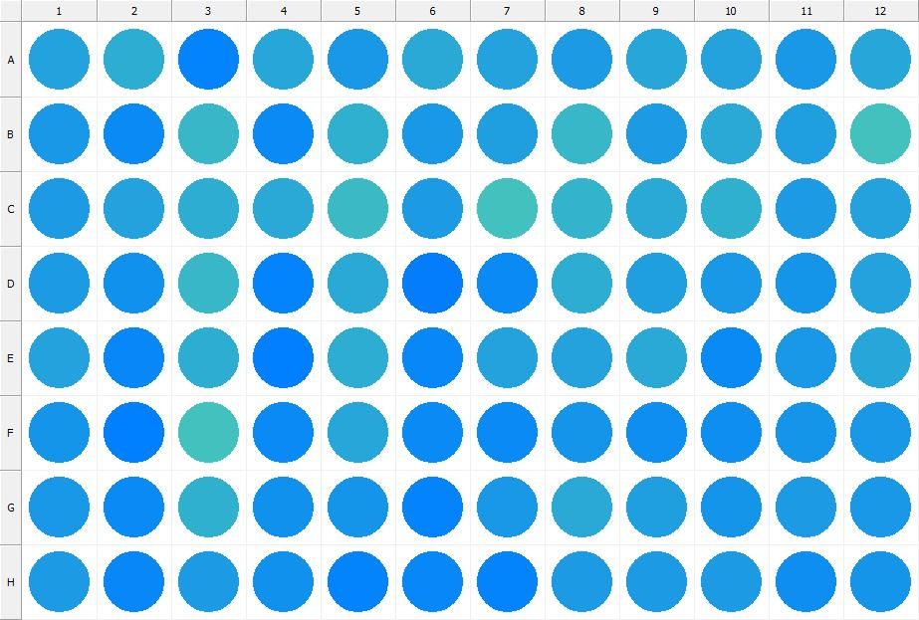

|  |
| --- |
| **Results for Tim_CTB(1) - channel 1 (RFU)** |

|  |  |  |  |  |  |  |  |  |  |  |  |  |
| --- | --- | --- | --- | --- | --- | --- | --- | --- | --- | --- | --- | --- |
|  | 01 | 02 | 03 | 04 | 05 | 06 | 07 | 08 | 09 | 10 | 11 | 12 |
| A | 109180 | 115531 | 88787 | 112100 | 103065 | 113993 | 109271 | 103748 | 111183 | 109600 | 102227 | 110546 |
| B | 101040 | 91773 | 121785 | 91882 | 118041 | 101519 | 105697 | 122998 | 104508 | 112944 | 107481 | 129933 |
| C | 103717 | 109556 | 116877 | 114600 | 125147 | 103487 | 128938 | 120090 | 114361 | 117694 | 104732 | 108660 |
| D | 103669 | 97413 | 122958 | 89278 | 113102 | 83290 | 93548 | 114862 | 107765 | 102930 | 98682 | 108847 |
| E | 109680 | 89573 | 115050 | 85331 | 115650 | 90628 | 109969 | 110136 | 113696 | 93188 | 101222 | 111451 |
| F | 100849 | 85032 | 129729 | 91938 | 111240 | 93169 | 92795 | 100520 | 94364 | 94255 | 100230 | 101456 |
| G | 102770 | 92668 | 119441 | 98537 | 99600 | 88103 | 103165 | 114478 | 107025 | 100073 | 105202 | 103208 |
| H | 104890 | 91298 | 104812 | 97771 | 89189 | 91418 | 88667 | 105485 | 103647 | 103880 | 95070 | 98695 |

|  |  |
| --- | --- |
| **Plate information** | |
|  | |
| **Plate** | 19 |
| **Repeat** | 1 |
| **Barcode** |  |
| **Measured height** | 14.78 |
| **Inside temperature at start** | 23.34 |
| **Inside temperature at end** | 23.34 |
| **Humidity at start** | 26.1 |
| **Humidity at end** | 26.2 |
| **Ambient temperature at start** | 22.76 |
| **Ambient temperature at end** | 22.76 |
| **Group** | 1 |
| **Label** | Tim_CTB(1) |
| **ScanX** | 0 |
| **ScanY** | 0 |
| **Measinfo** | De=1st Ex=Top Em=Top Wdw=N/A (14) |
| **Kinetics** | 0 |
| **Measurement date** | 12/12/2022 12:46:39 PM |
|  | |

|  |
| --- |
| **Background information** |
| Legend:  HDR1 - Plate  HDR2 - Label  HDR3 - Result  HDR4 - Signal  HDR5 - Flashes/Time  HDR6 - Meastime  HDR7 - MeasInfo |
| HDR1 HDR2 HDR3 HDR4 HDR5 HDR6 HDR7  20 Tim_CTB 0 1081 1 00:00:00.000 De=1st Ex=Top Em=Top Wdw=N/A (14) |
|  |

|  |  |
| --- | --- |
|  | |
| **Basic assay information** | |
| **Assay ID** | 24277 |
| **Assay Started** | 12/12/2022 12:30:26 PM |
| **Assay Finished** | 12/12/2022 12:48:02 PM |
| **Assay Exported** | 12/12/2022 12:49:42 PM |
| **Protocol ID** | 100568 |
| **Protocol Name** | Copy of 96well-CTB_Tim |
| **Serial#** | 1020141 |
|  | |
|  | |
|  | |
| **Protocol information** | |
| **Protocol:** | |
| **Protocol name** | Copy of 96well-CTB_Tim |
| **Number of assay repeats** | 1 |
| **Start assay repeat each** | N/A |
| **Number of plate repeats** | 1 |
| **Start plate repeat each** | N/A |
| **Is label meas. height used** | Yes |
| **Height of measurement** | Defined in label |
| **Is gripper height used** | No |
| **Mode of measurement** | By Rows, bi-directional |
| **Rotated plate** | No |
| **Soft move** | No |
| **Protocol notes** |  |
|  | |
| **Plate type:** | |
| **Name of the plate type** | 96 General |
| **Number of rows** | 8 |
| **Number of columns** | 12 |
| **Number of the wells in the plate** | 96 |
| **Height of the plate** | 14.35 mm |
|  | |
| **Coordinates of corners:** | |
| **96 General + Tim_CTB** | |
| 14.38 mm x------------------------------------------------------ x 113.38 mm  11.24 mm 11.24 mm | |
| 14.38 mm x------------------------------------------------------ x 113.38 mm  74.24 mm 74.24 mm | |
|  | |
|  | |

|  |  |
| --- | --- |
| **Platemap:** | |
| **Plate** | 1 |
| **Group** | 1 |
|  | |

|  |  |  |  |  |  |  |  |  |  |  |  |  |
| --- | --- | --- | --- | --- | --- | --- | --- | --- | --- | --- | --- | --- |
|  | **01** | **02** | **03** | **04** | **05** | **06** | **07** | **08** | **09** | **10** | **11** | **12** |
| **A** | - | - | - | - | - | - | - | - | - | - | - | - |
| **B** | - | - | - | - | - | - | - | - | - | - | - | - |
| **C** | - | - | - | - | - | - | - | - | - | - | - | - |
| **D** | - | - | - | - | - | - | - | - | - | - | - | - |
| **E** | - | - | - | - | - | - | - | - | - | - | - | - |
| **F** | - | - | - | - | - | - | - | - | - | - | - | - |
| **G** | - | - | - | - | - | - | - | - | - | - | - | - |
| **H** | - | - | - | - | - | - | - | - | - | - | - | - |

|  |  |
| --- | --- |
|  | |
| **-** | Undefined |
|  | |
|  | |

|  |  |
| --- | --- |
| **Calculations:** | |
| **No calculations.** | |
|  | |
| **Auto export parameters:** | |
| **Export format** | Plate2 |
| **Include basic assay information** | Yes |
| **Place assay information at** | End of file |
| **Include basic plate information** | Yes |
| **Place plate information at** | Beginning of plate |
| **Include protocol information** | Yes |
| **Protocol info level** | Large |
| **Include error and warning information** | Yes |
| **Include background information** | Yes |
| **Add plate number to the file name** | Yes |
| **Each plate to separate file** | No |
| **Field separator to use** | System |
| **File name format** | <DefaultDataFolder>\<Date>\<ProtocolName>_<AssayID>.csv |
|  | |
| **Operations:** | |
| Plate 1  Group 1  Measurement  Label..................................................... Tim_CTB(1) | |
| **Labels:** | |
| **Tim_CTB** | 4000137 |
| **Top mirror** | General |
| **Bottom mirror** | N/A |
| **Exc. filter** | Photometric 530 |
| **Using of excitation filter** | Top |
| **2nd exc. filter** | N/A |
| **Using of 2nd excitation filter** | Top |
| **Ems. filter** | Photometric 590 |
| **2nd ems. filter** | N/A |
| **Measurement height** | 6.5 mm |
| **Number of flashes** | 1 |
| **Number of flashes integrated** | 1 |
| **PMT gain** | 1 |
| **Excitation light** | 100% |
| **Reference excitation light** | 100% |
| **Emission light** | 100% |
| **Reference AD gain** | 4 |
| **Reference signal** | 383728 |
| **Last edited** | 2/11/2019 10:20:00 AM |
| **Last edited by** | EnVision |
| **Factory preset** | No |
|  | |
| **Filters:** | |
| **Photometric 530** | 310 |
| **Filter type** | Excitation |
| **Description** | P530 CWL=530nm BW=8nm Tmin=55% |
| **Used with** | Absorbance,DELFIA - Time-resolved Fluorescence,Fluorescence Intensity,Fluorescence Polarization,LANCE - Time-resolved Fluorescence |
| **Last edited** | 8/19/2014 4:24:21 PM |
| **Last edited by** | Installation |
| **Factory preset** | Yes |
|  | |
| **Photometric 590** | 314 |
| **Filter type** | Excitation |
| **Description** | P590 CWL=590nm BW=8nm Tmin=40% |
| **Used with** | Absorbance,DELFIA - Time-resolved Fluorescence,Fluorescence Intensity,Fluorescence Polarization,LANCE - Time-resolved FluorescenceAbsorbance,DELFIA - Time-resolved Fluorescence,Fluorescence Intensity,Fluorescence Polarization,LANCE - Time-resolved Fluorescence |
| **Last edited** | 8/19/2014 4:24:21 PM |
| **Last edited by** | Installation |
| **Factory preset** | Yes |
|  | |
| **Mirror modules:** | |
| **General** | 401 |
| **Used by** | Top |
| **Dual** | No |
| **Bias** | No |
| **Description** | BS50 |
| **Used with** | Luminescence,DELFIA - Time-resolved Fluorescence,Fluorescence Intensity,Fluorescence Polarization,LANCE - Time-resolved Fluorescence |
| **Last edited** | 8/19/2014 4:24:21 PM |
| **Last edited by** | Installation |
| **Factory preset** | Yes |
|  | |
| **Instrument:** | |
| **Serial number** | 1020141 |
| **Nickname** | EnVision |
|  | |
|  | |
|  | |
|  | |
| **Notifications:** | |
| Assay notifications:  INFO: Assay aborted at plate 20 plate repeat 1 and well H01. There may be missing results | |
|  | |
|  | |

|  |
| --- |
|  |
| **Exported with EnVision Workstation version 1.13.3009.1409** |